Einführung in das Thema Sicherheit
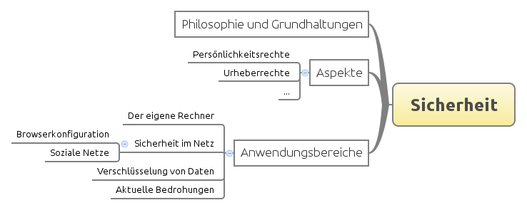

Zitate zum Thema
- There is no such thing as a free lunch.
- Daten sind das Erdöl des 21. Jahrhunderts.

Zwischen Spackeria und Datenschützern
- Kritische Position
- Stützende Position

Kleine Erinnerung ...
Gary Kovacs: Tracking the trackers
<html> <object width=„526“ height=„374“> <param name=„movie“ value=„http://video.ted.com/assets/player/swf/EmbedPlayer.swf“></param> <param name=„allowFullScreen“ value=„true“ /> <param name=„allowScriptAccess“ value=„always“/> <param name=„wmode“ value=„transparent“></param> <param name=„bgColor“ value=„#ffffff“></param> <param name=„flashvars“ value=„vu=http://video.ted.com/talk/stream/2012U/Blank/GaryKovacs_2012U-320k.mp4&su=http://images.ted.com/images/ted/tedindex/embed-posters/GaryKovacs_2012U-embed.jpg&vw=512&vh=288&ap=0&ti=1436&lang=&introDuration=15330&adDuration=4000&postAdDuration=830&adKeys=talk=gary_kovacs_tracking_the_trackers;year=2012;theme=what_s_next_in_tech;theme=technology_history_and_destiny;theme=not_business_as_usual;event=TED2012;tag=Internet;tag=business;tag=technology;&preAdTag=tconf.ted/embed;tile=1;sz=512x288;“ /> <embed src=„http://video.ted.com/assets/player/swf/EmbedPlayer.swf“ pluginspace=„http://www.macromedia.com/go/getflashplayer“ type=„application/x-shockwave-flash“ wmode=„transparent“ bgColor=„#ffffff“ width=„526“ height=„374“ allowFullScreen=„true“ allowScriptAccess=„always“ flashvars=„vu=http://video.ted.com/talk/stream/2012U/Blank/GaryKovacs_2012U-320k.mp4&su=http://images.ted.com/images/ted/tedindex/embed-posters/GaryKovacs_2012U-embed.jpg&vw=512&vh=288&ap=0&ti=1436&lang=&introDuration=15330&adDuration=4000&postAdDuration=830&adKeys=talk=gary_kovacs_tracking_the_trackers;year=2012;theme=what_s_next_in_tech;theme=technology_history_and_destiny;theme=not_business_as_usual;event=TED2012;tag=Internet;tag=business;tag=technology;&preAdTag=tconf.ted/embed;tile=1;sz=512x288;“></embed> </object> </html>
https://addons.mozilla.org/de/firefox/addon/collusion/

Weiter: Grundlagen

